# Task 1 (Uploading Files)

## Screenshot of uploaded files {AwardsCoaches.csv, Coaches.csv, Master.csv}

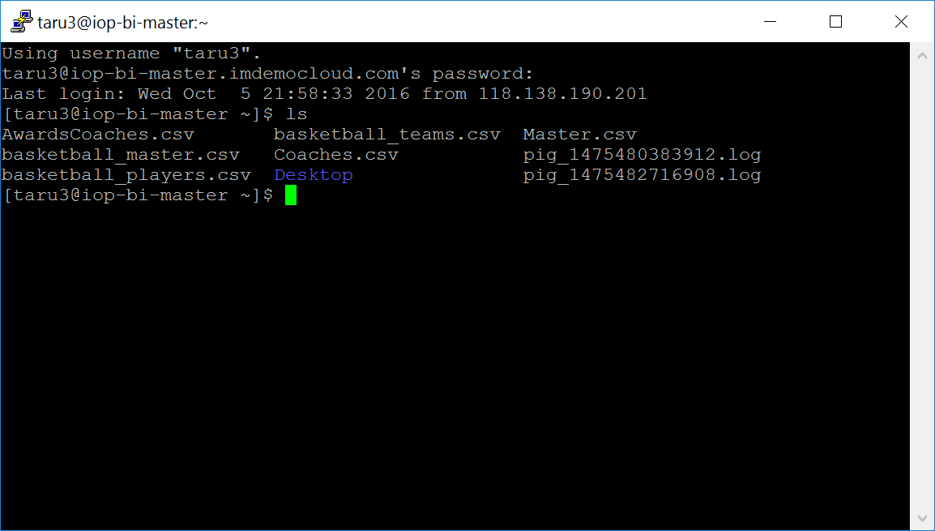

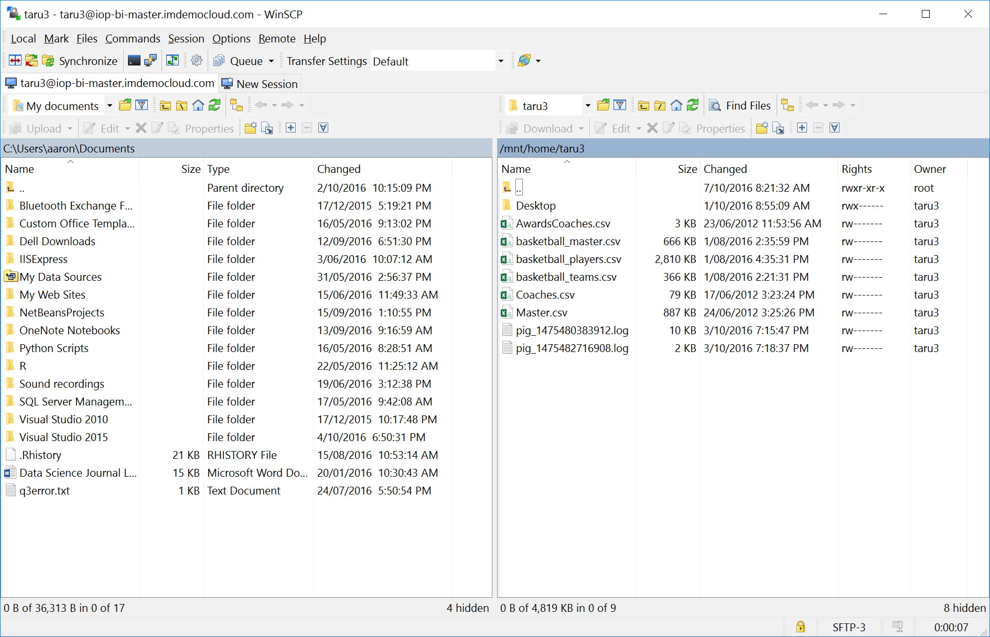

## List of tables {p_awardscoaches, p_coaches, p_master}

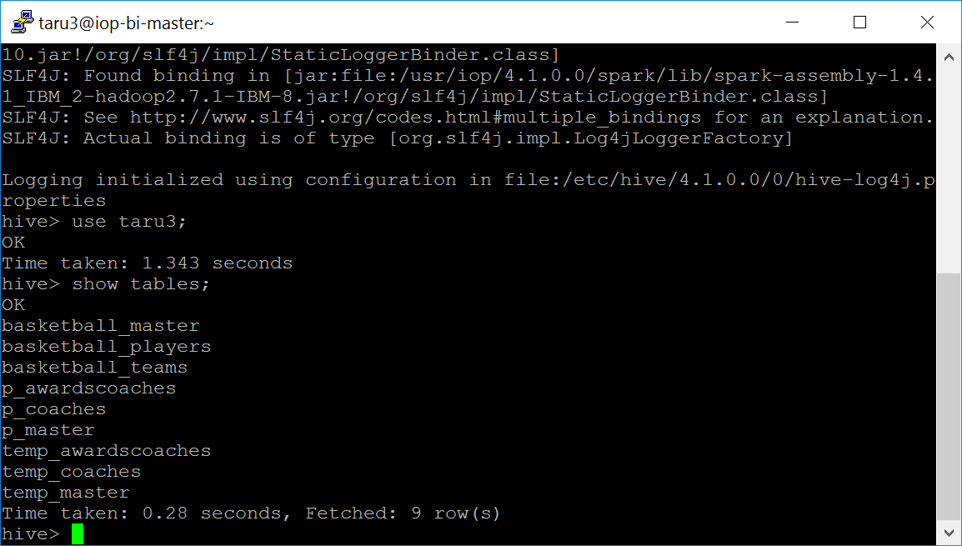

## Describe p_awardscoaches

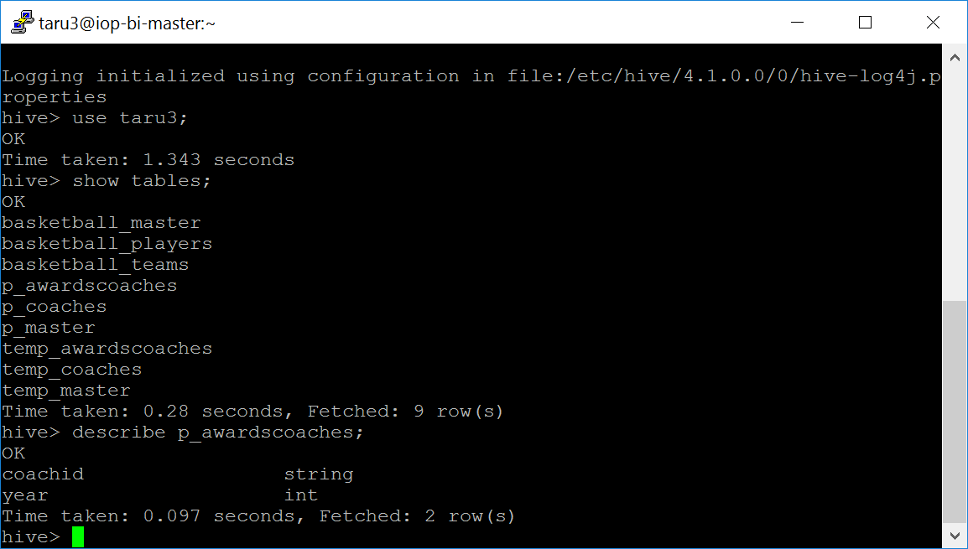

## Describe p_coaches

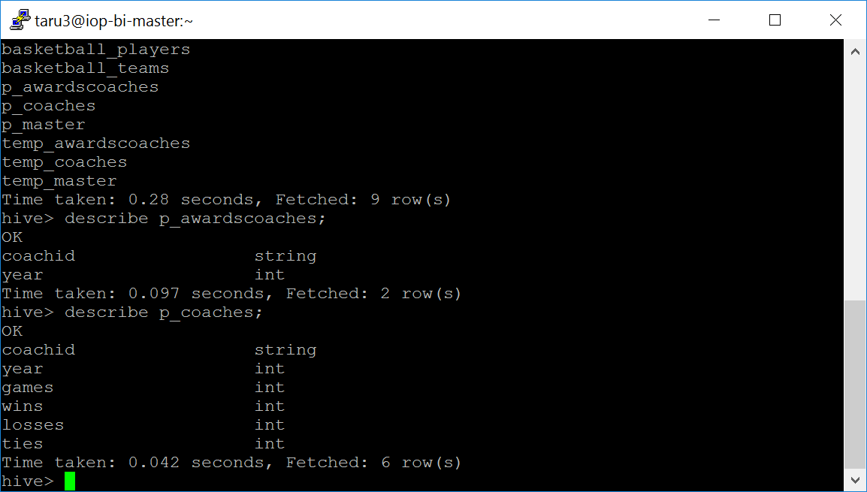

## Describe p_master

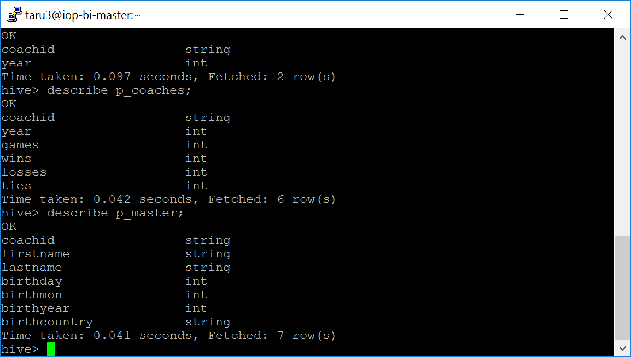

# Task 3 Coaches

## Coaches with more than 1 award

